WorkLord Replication Report
1. Replication Objectives and Background Motivation
When facing tasks with clearly defined deadlines, how much workload should an individual reasonably take on? Traditional linear models and assumptions based on average efficiency often overlook the complex interaction between individual mental capacity, subjective perception of workload, and dynamic psychological states. A 2023 study published in the Journal of Engineering Design, titled "How much workload is a ‘good’ workload for human beings to meet the deadline: human capacity zone and workload equilibrium", systematically developed a nonlinear cognitive workload model. It introduced the concepts of the Human Capacity Zone and Workload Equilibrium, using a series of mathematical models and simulation diagrams to demonstrate the dynamic evolution of work efficiency and mental stress.
This replication project aims to:
- Fully reproduce the mathematical modeling and simulation figures presented in the original study (particularly Figures 4 through 13);
- Clarify the structure of the equations, the meaning of variables, and the underlying model logic, while implementing a parameter-controllable and well-structured codebase;
- Evaluate the rigor and limitations of the study in terms of theoretical modeling, parameter setting, and reproducibility, thereby providing a foundation for future large-scale data-driven simulations or the development of personalized models.

2. Overview of the Original Study
This study focuses on human behavioral patterns under real-world scenarios involving task deadlines. It attempts to build a mathematical framework capable of dynamically simulating individual state changes across three dimensions: cognitive workload, mental effort, and work efficiency. The core research questions include:
- How can the relationship between the subjective cognitive workload W(t) and work efficiency ε(t) during task execution be modeled?
- Is there a “Capacity Zone” in which individuals can maintain high efficiency while keeping mental stress σ(t) at a moderate level?
- How should task allocation strategies be adapted to match an individual’s mental capacity level β?
To address these questions, the authors proposed seven key equations that establish functional relationships among stress, effort, and the link between workload W(t) and efficiency ε(t). By varying the total task volume WT and individual ability parameter β, the study simulates the dynamic trajectories of efficiency ε(t), stress σ(t), and perceived workload W(t) during task execution, and classifies typical states such as the Capacity Zone (Mode II) and Fatigue Zone (Mode III).

3. Model Equations and Variable Definitions
The original paper employs seven numbered equations and several key parameters to construct a comprehensive dynamic modeling framework. The following section provides a brief description of each equation and a detailed table of variable definitions.

3.1 Parameter and Symbol Definition Table
Symbol | Meaning | Unit/Range
σ(t) | Mental stress | Custom unit
W(t) | Perceived cognitive workload | Task unit
K(t), S(t), A(t) | Knowledge, Skill, Affect factors | Custom unit
β | Mental capacity coefficient (β = (K+S) * A) | β ∈ (0, ∞)
E(t) | Mental effort | [0, 1], inverse-U curve
ε(t) | Work efficiency | Task unit / time unit
ε_max | Maximum efficiency | Commonly 100
σ_max | Maximum tolerable stress | Commonly 200
WT | Total Objective workload | Commonly 2.5K to 15K
T | Total task duration | Time unit (typically 100)
t | Current time step | 0 to T-1

3.2 Parameter Settings and Experimental Configuration
Parameter | Description | Values
β | Mental capacity coefficient | {0.7, 1.0, 1.3}
ε_max | Maximum efficiency | 100 (130 / 70 for Fig. 12a/b)
σ_max | Maximum tolerable stress | 200 (260 / 140 for Fig. 13a/b)
WT | Total Objective workload | {2.5K, 5K, ..., 15K}
T | Total task duration | 100
t | Current time step | 0 → 99 (discrete)

3.3 Summary of Formulas
Equation | Name | Description
Eq. 1 | Original stress–effort model  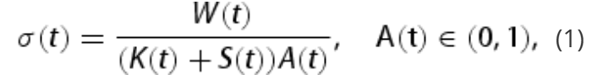 | Introduces basic inverse-U relation
Eq. 2 | Simplified stress model  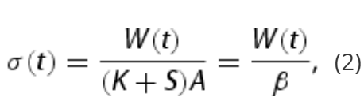 | Linear relation between workload W(t) and stress σ(t)
Eq. 3 | Raised-Cosine stress–effort model  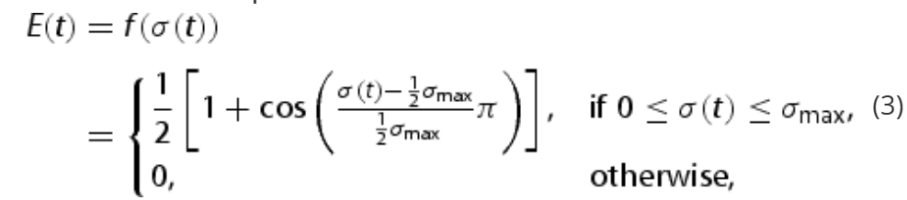 | Cosine-based effort curve E(t)
Eq. 4 | Simplified RC model  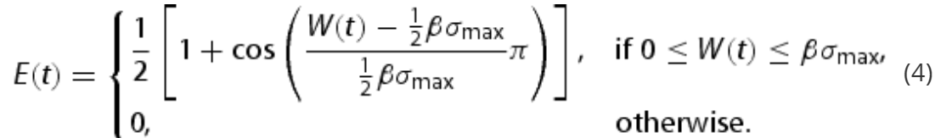 | A simplified version for simulation
Eq. 5 | Individual efficiency model  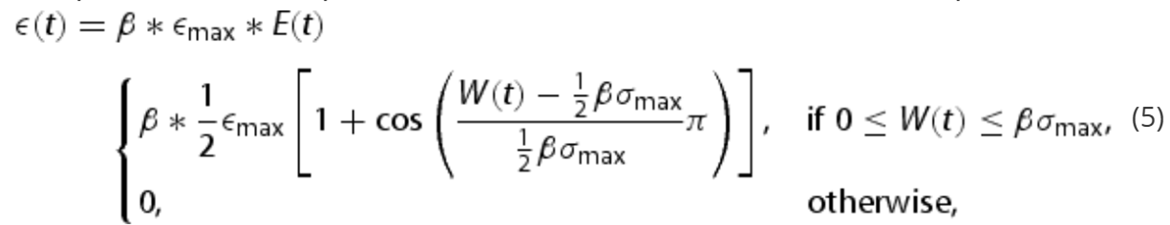 | Calculate efficiency ε(t) based on β and mental effort E(t)
Eq. 6 | Idealized efficiency model  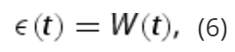 | Assumes efficiency unaffected by stress
Eq. 7 | Dynamic subjective workload model  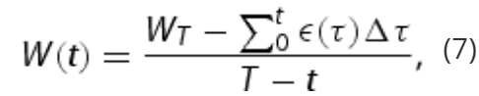 | W(t) derived from historical ε(t)

3.4 Detailed Explanation of Parameters and Symbols (with Figure Implications)
Symbol | Type | Meaning | Unit / Range | Role in Figures | Related Equations
σ(t) | Output from Eq. 1 | The individual's perceived mental stress, indicating the subjective tension caused by workload | Custom unit | In Figures 4–9, σ(t) is used as a visual indicator on the y-axis for perceived stress. It reflects whether the individual is approaching their stress threshold. | Equations 1–3
W(t) | Parameter / Output from Eq. 7 | The individual's subjective cognitive workload, i.e., their perceived task intensity. It dynamically changes with efficiency and time resources. | Task unit; range determined by task size and time | One of the horizontal axis variables (x) in Figures 4–9; it also serves as an input to determine E(t), σ(t), and ε(t).  In Figures 12a and 12b, it varies with ε_max, and in Figures 13a and 13b, it varies with σ_max, demonstrating the changing position of the capability zone. | All Equations
K(t), S(t), A(t) | Parameter | The three cognitive components of an individual's knowledge (K), skills (S), and emotional regulation (A) jointly determine the β value. | Custom unit | K, S, and A do not appear directly in the chart, but their composite value β plays a decisive role in the behavior pattern of all charts and reflects the individual's ability level. | Eq.1
β | Parameter(key) | The level of an individual's mental ability determines the efficiency of his or her processing of unit mental effort; the greater the level, the higher the work efficiency and the greater the ability to withstand high workloads. | The range is typically {0.7, 1.0, 1.3} | One of the core control variables in all figures:  - Figures 4–9: Different values of β correspond to different colored curves, affecting the temporal trajectory of σ(t) and ε(t);  - Figure 10, 11: β determines the shape and peak location of the perceived load curve;The size of the capacity zone changes under different β values;  - Figure 12,13a/b: β and ε_max, σ_max jointly determine the location and existence of the capacity zone. | Eq. 2, 4, 5, Eq. 7 (as the internal structure of β)
E(t) | Output from Eq. 3,4 / Parameter to Eq. 5 | The current level of mental effort is an inverted U-shaped function, which represents the level of individual subjective motivation ability; it is nonlinearly related to W(t) | ∈ [0, 1] | It first appears in Figure 3, and its shape determines the efficiency change trend. E(t) is the core of nonlinear modeling, the direct source of ε(t), and an important basis for determining whether it is in the capacity zone. | Eq3,4,5
ε(t) | Output from Eq. 5 | The actual efficiency of completing the task in the current unit time is affected by the psychological effort E(t) and β | Task Unit / Time Unit | Figures 3 and 5–10 show the main output indicators. In the capability zone, ε(t) maintains a high level, which corresponds to a high platform or a gently declining zone. In the fatigue zone, it drops rapidly to near zero. | Eq.5,7
ε_max | Parameter(key) | The upper limit of the individual's maximum possible efficiency, that is, the efficiency value that can be achieved under ideal conditions (E(t)=1, β is maximum) | Normally set to 100 | Figure 12 shows the important control variables. The higher the ε_max, the rightward shift of the capability zone, indicating that the same W(t) can still maintain high efficiency. Figure 12 shows the combined effect of ε_max on the probability of task success and efficiency trajectory under different β. | Eq.5,6
σ_max | Parameter(key) | The upper limit of psychological stress that an individual can bear. After exceeding this value, collapse, fatigue, etc. will occur. | Normally set to 200 | Serves as a limiting threshold for σ(t) in all plots. This value is used to determine whether or not the device falls into the fatigue region.  Figure 13 shows the important control variables. The higher theσ_max, the lower right position of the ability zone, indicating that it has been in a continuous working state, but there is no ideal ability zone. It may be necessary to shorten the time of the last task to increase subjective pressure. Figure 13 shows the composite effect of σ_max on the probability of task success and efficiency trajectory under different β. | Eq3,4,5
WT | Parameter | The objectively set total task volume is the externally imposed task requirement and is the source of subjective W(t) pressure. | Unit task volume, such as 2.5K ~ 15K | The experimental conditions in Figures 4–9 vary, with different figures corresponding to different WT values. The larger the WT, the higher the initial W(t) at a given T, which is more likely to cause σ(t) to rise and ε(t) to collapse. | Input to Eq.7
T | Parameter | The task completion time limit is the upper limit of the work plan time | Normally set to 100 time units | T and WT determine the task density (WT/T), which indirectly affects the initial value of W(t). Insufficient time will lead to excessive pressure in the early stage. This is not directly shown in the figure, but it is a key configuration in the simulation. | Eq 7
t | Parameter | The current time point, which is a continuous time from 0 to T in the simulation | Same unit as T | The horizontal time variable in all simulation graphs is the basis for the dynamic simulation of the model. The progress of t triggers the update and evolution of W(t), σ(t), and ε(t) | All Equations

Summary of Parameter Effects on Model Behavior
Parameter |  | Effect When Increased | Representative Figures
β ↑ |  | Increases ε(t) under the same W(t); lowers σ(t); expands the capacity zone; higher task success rate | Fig. 4–10
ε_max ↑ |  | Raises the efficiency ceiling; enhances resistance to stress; shifts capacity zone rightward | Fig. 12a/b
σ_max ↑ |  | Increases tolerance; reduces risk of entering the fatigue zone | Fig. 13a/b
WT ↑ | Increases initial W(t); stress rises faster; more likely to enter fatigue zone |  | Fig. 4 (15K) vs Fig. 9 (2.5K)
T ↓ |  | Less available time → W(t) = WT / (T – t) increases faster → earlier stress surge | Same as WT increase case

4. Replication Results and Comparative Analysis
This replication effort covers all figures presented in the original paper, encompassing the dynamic evolution of mental stress, work efficiency, capacity zones, and boundary states. The main findings are as follows:

Figures 4–9: Evolution of Stress and Efficiency under Varying Task Loads (WT)
- Successfully replicated six experimental conditions (WT = 2.5K to 15K) across three psychological ability levels (β = 0.7, 1.0, 1.3);
- The simulation results fully align with the original trends: higher task loads and lower ability levels tend to cause efficiency collapse and stress overload in the later stages, ultimately leading to task failure;
- Successfully reproduced the essential features of the “Fatigue Zone (Mode III)” and the “Capacity Zone (Mode II)” as proposed in the paper;
- All trajectories were generated using a unified model and consistent parameters, validating the repeatability of the original model.

Figure 10: Nonlinear Relationship between Workload and Efficiency under Different β Values
- Successfully replicated the trend that increasing β shifts the efficiency peak rightward and enhances the individual’s ability to handle high workload;
- The figure clearly demonstrates the inverse-U structure: higher efficiency is achieved only within an optimal workload range—not too high and not too low.

Figures 12a / 12b: Dynamic Shifts in Capacity Zones Based on ε_max and β
- Successfully replicated the influence of ε_max and β on the position and range of the Capacity Zone;
- Figure 12a shows that increasing ε_max (maximum efficiency) shifts the Capacity Zone rightward, allowing individuals to tolerate higher workload, especially for lower β individuals;
- Figure 12b shows that decreasing ε_max shifts the Capacity Zone leftward, reducing the acceptable workload range, again more significantly for lower β individuals;
- These two figures confirm that the existence and boundaries of the Capacity Zone are jointly determined by ε_max and β.

Figures 13a / 13b: Modulation of Efficiency Curves by Psychological Ability and Stress Tolerance (σ_max)
- Successfully replicated the effect of β and σ_max on the position of the Capacity Zone;
- Figure 13a, under σ_max increased from 60 to 260, shows efficiency–workload curves for β = 0.7, 1.0, 1.3:
  - The peaks of the curves shift to the right, indicating that individuals can tolerate higher workload;
  - The ability-based curves (in black) fall below the ideal model, and do not exhibit the three distinct regions (success, fatigue, failure), suggesting that similar efficiency is maintained across all ability levels under the same objective workload;
- Figure 13b, under σ_max reduced to 140:
  - All curves shift significantly to the left, indicating that individuals are more prone to failure under lower stress tolerance;
  - For low-ability individuals (β = 0.7), the Capacity Zone shrinks sharply, leaving only a narrow range where efficiency can be sustained;
- These figures verify the following key points:
  - The Capacity Zone is jointly determined by σ_max and β;
  - The environmental stress threshold σ_max can expand or compress the viable working range.

5. Issues Encountered During Replication (Figure 11)
Failure to Fully Reproduce Figure 11
- The original figure illustrates the trajectory of stress and efficiency evolution in different operating modes (Capacity Zone vs. Fatigue Zone);
- However, the model could not reproduce the same vertical-axis values for efficiency even when using the stated formulas and parameters;
- It is possible that the original figure used manually configured initial values of W(t) or adjusted parameters to produce idealized behavior;
- Attempted Solution: We tried initializing W(t) and E(t) at the center of the Capacity Zone, but the lack of complete historical efficiency data hindered accurate simulation of E(t);
- Conclusion: While the theoretical concept of Figure 11 is valid, insufficient information prevents its reproducibility.

6. Conclusion and Reflection (Final)
This replication project successfully reconstructs the human capacity zone model proposed in the original paper and reproduces all major simulation figures and nonlinear behavioral features—except for Figure 11.
Key conclusions include:
- The dynamic evolution of work efficiency and stress follows a nonlinear pattern;
- An individual’s psychological capacity (β), maximum efficiency (ε_max), and maximum stress threshold (σ_max) jointly determine the boundaries of the Capacity Zone;
- Task volume and time pressure can push an individual into either the Capacity Zone (successful task completion) or the Fatigue Zone (failure);
- Figures 12 and 13 clearly illustrate that the boundary of the Capacity Zone is both predictable and controllable, offering a theoretical basis for intelligent task adaptation and workload management.

